CLI – Øvelsestimer

Øvelsestime 1
Problem 1.1 Given the following sets S = {1; 2; 3; 6; 7; 9} and R = {2; 4; 5; 6; 7} state
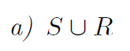
- {1, 2, 3, 4, 5, 6, 7, 9}
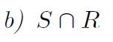
- {2, 6, 7}
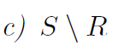
- {1, 3, 9}
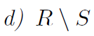
- {4, 5}
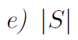
- 6
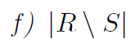
- 2

Problem 1.2 State these expression as simple rational numbers or fractions:
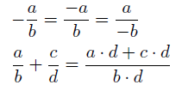
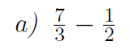
$$\frac{7*2}{3*2}-\frac{1*3}{2*3}=$$
$$\frac{14}{6}-\frac{3}{6}=$$
$$\frac{11}{6}$$

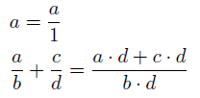
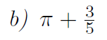
$$pi=3,14$$
$$\frac{3}{5}=0,6$$
$$3,14+0,6=$$
$$3,74$$
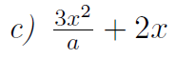
$$a=\frac{1}{x}$$
$$\frac{3x^{2}}{a}+\frac{2x}{1}=$$
$$\frac{3x^{2}}{a} +\frac{a*2x}{a*1}=$$
$$\frac{3x^{2}}{a} +\frac{a*2x}{a}=$$
$$\frac{3x^{2}}{a}+\frac{2ax}{a}=$$
$$\frac{3x^{2}+2ax}{a}$$
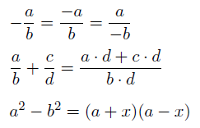
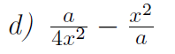
$$\frac{a*a}{4x^{2}*a}-\frac{{4x^{2}*x}^{2}}{4x^{2}*a}=$$
$$\frac{a^{2}}{4ax^{2}}-\frac{4x^{4}}{4ax^{2}}=$$
$$\frac{a^{2}-4x^{4}}{4ax^{2}}$$

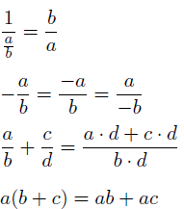
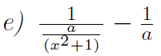
$$\frac{x^{2}+1}{a}-\frac{-1}{a}=$$
$$\frac{x^{2}+1}{a}+\frac{-1}{a}=$$
$$\frac{\left(x^{2}+1\right)a-1*a}{a*a}=$$
$$\frac{a*x^{2}+a-a}{a^{2}}=$$
$$\frac{a*x^{2}}{a^{2}}=$$
$$\frac{x^{2}}{a}$$

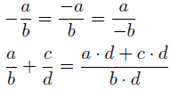
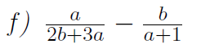
$$\frac{a}{2b+3a}+\frac{-b}{a+1}=$$
$$\frac{a\left(a+1\right)-\left(2b+3a\right)b}{\left(2b+3a\right)\left(a+1\right)}=$$

Problem 1.3 Using the rules for exponentials simplify the following expressions:
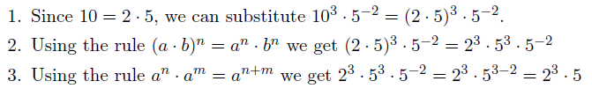
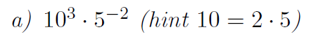
$${10}^{3}*5^{-2}=$$
$$2^{3}*5^{3}*\frac{1}{5^{2}}=$$
$$2^{3}*5^{3}*\frac{1}{5^{2}} =$$
$$2^{3}*5*1=$$
$$2^{3}*5=$$
$$8*5=$$
$$40$$
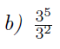
$$\frac{3^{5}}{3^{2}}=$$
$$3^{5-2}=$$
$$3^{3}$$
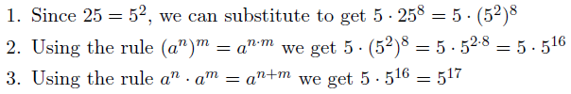
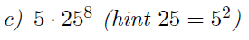
$$5*{\left(5^{2}\right)}^{8}=$$
$$5*5^{2*8}=$$
$$5*5^{16}=$$
$$5^{1}*5^{16}=$$
$$5^{17}$$
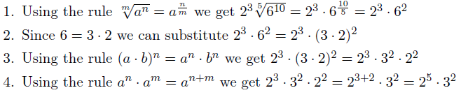
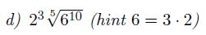
$$2^{3}*6^{\frac{10}{5}}=$$
$$2^{3}*6^{\frac{10/5}{5/5}}=$$
$$2^{3}*6^{\frac{2}{1}}=$$
$$2^{3}*6^{2}=$$
$$2^{3}*{\left(2*3\right)}^{2}=$$
$$2^{3}*2^{2}*3^{2}=$$
$$2^{5}*3^{2}$$
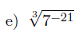
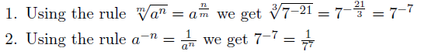
$$7^{\frac{-21}{3}}=$$
$$7^{\frac{-7}{1}}=$$
$$7^{-7}=$$
$$\frac{1}{7^{7}}$$
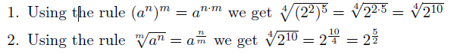
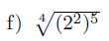
$$\sqrt[4]{2^{2*5}}=$$
$$\sqrt[4]{2^{10}}=$$
$$2^{\frac{10}{4}}=$$
$$2^{\frac{5}{2}}$$

Problem 1.4 Write the following inequalities as intervals of the real line
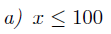
Numbers smaller or equal than 100: (-∞; 100]
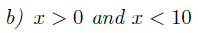
Numbers between 0 and 10 (not included) (0; 10)
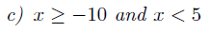
Numbers larger or equal than -10 and smaller than 5: [-10; 5)
Numbers larger or equal than -1: [-1, ∞)
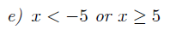
Numbers smaller than -5 or larger than 5: (-∞; -5) U [5; ∞)
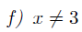
Numbers different than 3: (-∞,∞) \ {3} or (-∞, 3) U (3; ∞)

Problem 1.5 Solve the following inequalities for x:
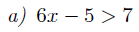
$$6x-5+5>7+5=$$
$$6x>12=$$
$$\frac{6}{6}*x>\frac{12}{6}=$$
$$x>2 (2, ∞)$$
$$-\frac{2x}{-2}<\frac{4}{-2} =$$
$$x>-2(-∞;-2)$$
$$5x-3+3<7+3-3x=$$
$$5x<10-3x=$$
$$5x+3x<10-3x+3x =$$
$$8x<10=$$
$$\frac{8x}{8}<\frac{10}{8}=$$
$$x=\frac{\frac{10}{2}}{\frac{8}{2}}=$$
$$x=\frac{5}{4}$$
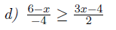
$$4*\frac{6-x}{-4}>4*\frac{3x-4}{2}=$$
$$- \left(6-x\right)>2*\left(3x-4\right)=$$
$$-6+x>6x-8=$$
$$-6+6+x-6x>-8+6=$$
$$x-6x>-2=$$
$$5x>-2=$$
$$\frac{-5x}{-5}> \frac{-2}{-5}=$$
$$x=\frac{2}{5}$$
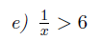
$$\frac{1}{x}-6>6-6=$$
$$\frac{1-6}{x}>0=$$
$$1-6x>0=$$
$$-1+1-6x>-1=$$
$$-6x>-1=$$
$$-\frac{6}{-6}*x>-\frac{1}{-6}=$$
$$x>\frac{1}{6} (0, \frac{1}{6})$$

